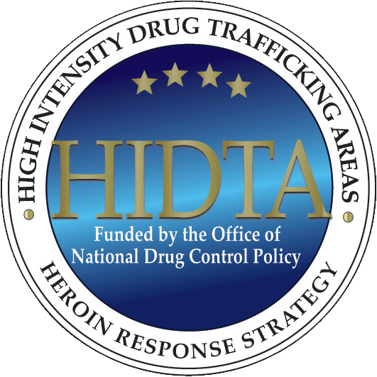
Heroin Response Strategy
Investing in partnerships to build safe and healthy communities

Overview
The Heroin Response Strategy (HRS) is an initiative designed to enhance public health-public safety collaboration and to strengthen and improve efforts to reduce drug overdose deaths across 8 High Intensity Drug Trafficking Areas (HIDTAs).

The mission of the HRS is to reduce fatal and non-fatal opioid overdose incidents by developing and sharing information about heroin and other opioids across agencies
The HRS currently spans 20 states: Maine, New Hampshire, Vermont, Massachusetts, Rhode Island, Connecticut, New York, New Jersey, Delaware, Pennsylvania, Ohio, Michigan, Virginia, Maryland, West Virginia, Kentucky, Tennessee, North Carolina, South Carolina, and Georgia.
and disciplines, and by offering evidence-based intervention strategies.

With support from the Office of National Drug Control Policy (ONDCP) and the Centers for Disease Control and Prevention (CDC), an HRS Public Health Analyst (PHA) and a Drug Intelligence Officer (DIO) are assigned to each HRS state, working to build infrastructure to support inter-agency communication and cross-disciplinary collaboration.

PHAs and DIOs work collaboratively with various local, state, and federal agencies to gather, analyze, and disseminate vital information about drug abuse with a focus on actionable intelligence, trend information, and best practices for developing evidence-based responses to the opioid epidemic in their area.

Each PHA and DIO is supported by a Regional Point of Contact (POC) who provides regular communication; connects PHAs and DIOs to resources and subject matter experts; provides guidance on work plan development and the fulfillment of various reporting requirements; assists with the onboarding process to orient new PHAs and DIOs to the HRS; and facilitates PHA/DIO collaboration.

Initiative Goals
- Create and coordinate shared data regimes that allow public health, law enforcement, and others to respond quickly and effectively to the opioid overdose epidemic.

- Develop and support strategic, evidence-based responses to generate immediate reductions in the number of overdose-related fatalities.

- Promote and support efforts to prevent or reduce opioid misuse.

- Promote the active engagement of local communities in the discussion, planning, and implementation of HRS goals and activities.

